Domenico Gioffre

1977 Cessna 172 Skyhawk rudder and rudder control systems

Writing for Engineers

Danielle Carr

March 9, 2021

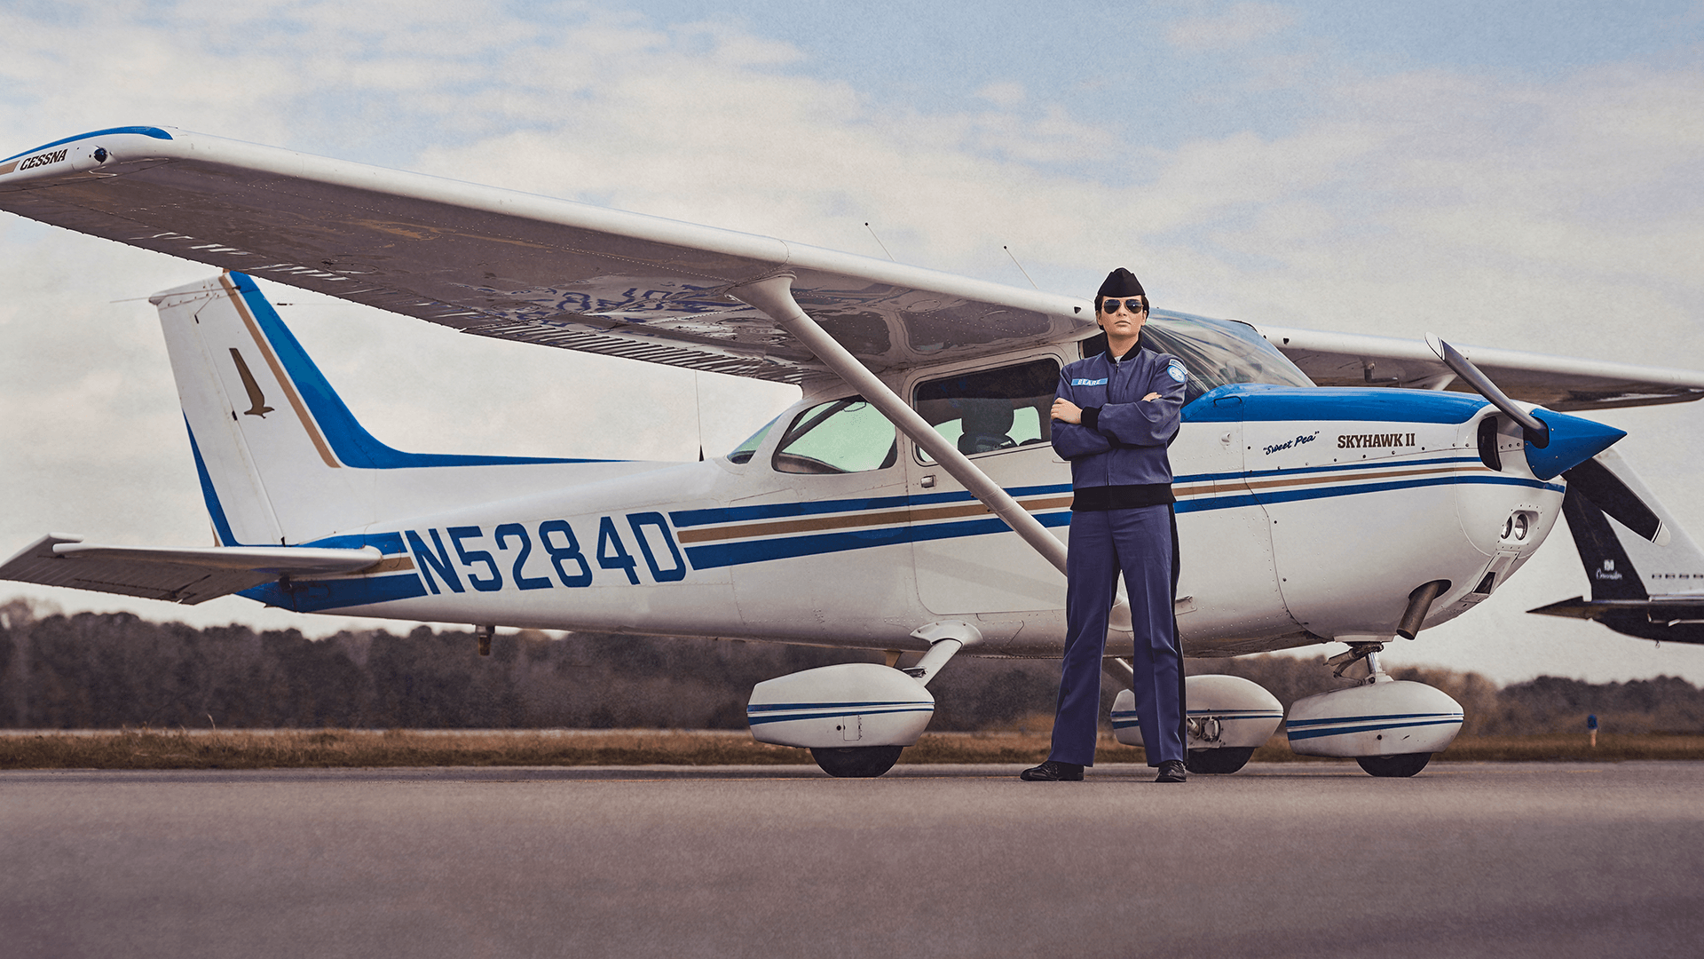

Cessna 172 Skyhawk and pilot

Table of Contents Page #

1. Introduction/History........................................................................................................................3
   1. The Cessna Company.........................................................................................................3
   2. The Skyhawk......................................................................................................................5
   3. Introduction to yaw.............................................................................................................6
2. Cessna Rudder Control Surfaces......................................................................................................7
   1. The Vertical Stabilizer.......................................................................................................7
   2. The Rudder..........................................................................................................................8
3. Cessna Rudder Control Mechanism...............................................................................................10
   1. Cables................................................................................................................................10
   2. Pedals................................................................................................................................10
4. Conclusion.....................................................................................................................................11
5. References.....................................................................................................................................12

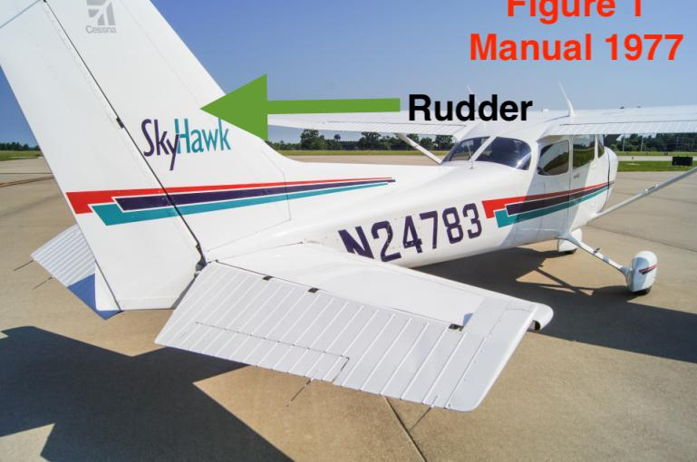



**Cessna 172 Skyhawk Rudder, the subject of this document.**

**Chapter 1: INTRODUCTION/HISTORY**

The Cessna 172 Skyhawk has become the most iconic plane ever built. Its systems are reliable and intuitive, making this aircraft perfect for beginners and experienced flyers alike. One of the 172’s reliable systems are its rudder. To completely understand the rudder and its systems, one needs to understand who was designing the rudder, and why.   
 That is why we begin with this technical description with the historical context of the Cessna Company.



**Part A: The Cessna Company**



The Cessna Company

Cessna Aircraft was founded in 1927 by Clyde Cessna (Murrow 1990). Clyde Cessna was a farmer in Kansas who constructed aircraft from wood. The 1920’s was known as the “booming age” of flying. Just before World War I (1914-1918), engines became smaller and more powerful, allowing powered flight to finally become feasible.



Following 1927, Clyde and the new company released a limited but successful number of aircraft, notably the DC-6, which was used as a trainer by the Army Air Corps (Pan Am Historical Foundation, 1987). The company closed its doors in 1931 due to the Great Depression (1929-1933). However, amid the Great Depression, a previously released aircraft, the Cessna CR-3, became immensely popular and demanded, notably due to its top speed of 237mph (Murrows, 1990).



The success of the Cessna CR-3 gave Clyde Cessna’s nephews, Dane and Dwight Wallace, the confidence to buy and reopen the company in 1934. This gamble would prove a massive success. In 1940, with World War II rolling, the US Army and Canadian Air Force ordered 213 multi-engine trainer aircraft (aircraft designed to train new pilots to planes with more than one engine) from Cessna (Cessna History, 1969).



In 1946, Cessna released the Model 140, which was labeled by the US Flight Instructors Association as the “Outstanding Plane of the Year” in 1948 (Cessna 140, 2009). The Model 140 was a great plane, but soon began to show its faults in the next decade. Most notably the Model 140 was underpowered, with its Lycoming engine only producing 85 horsepower (Cessna History, 1969).

Additionally, the Model 140 had its centerline gear on the tail of the aircraft. This gave it a tendency to fall forward on its nose on heavy braking during landing (Price, 2019). The Model 140 is shown below in figure 2 (Shupek, 2005). Highlighted are the common points of reference for all aircraft.

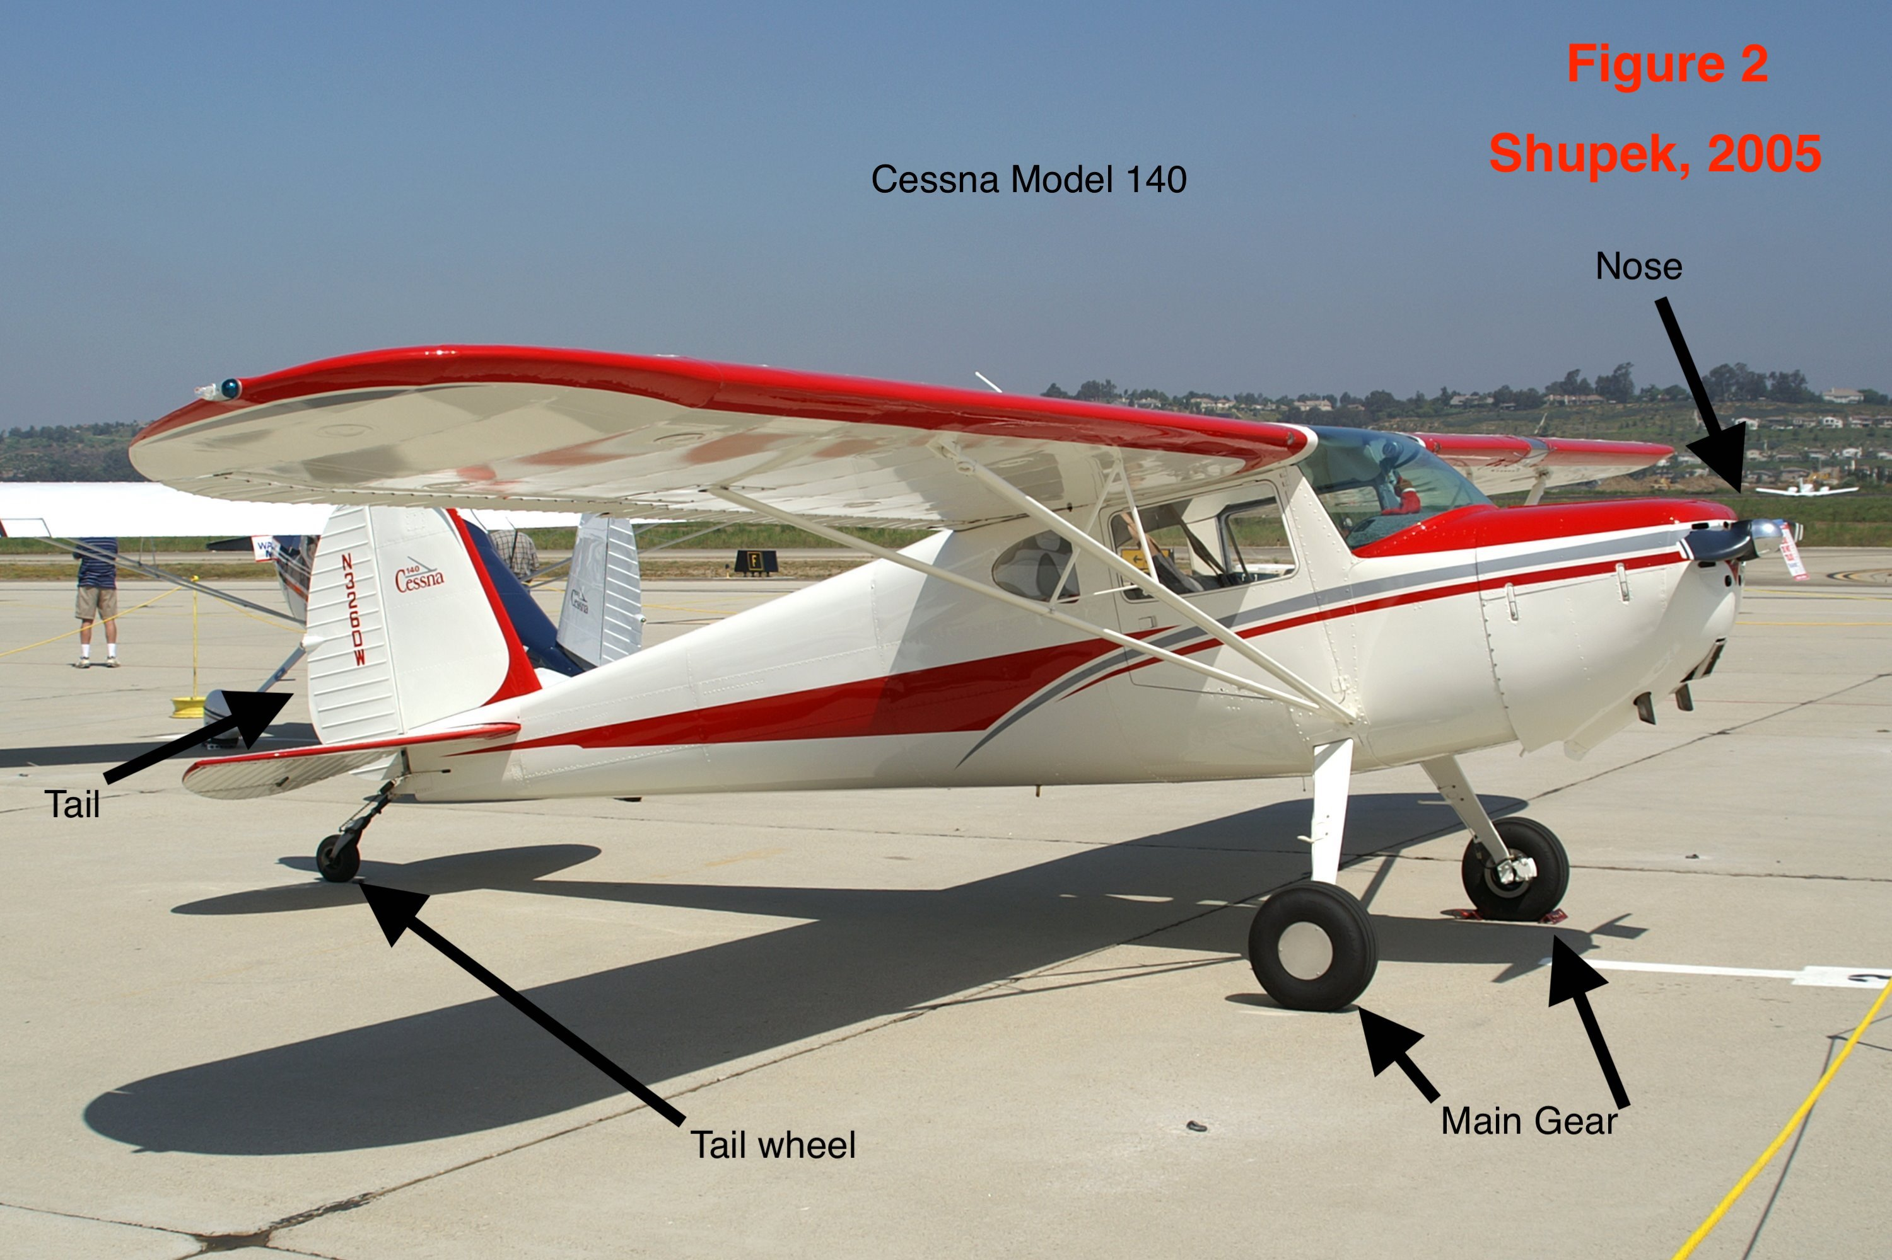

To combat these issues, Cessna released the Cessna 172 Skyhawk. The Skyhawk became the most successful aircraft ever released, with 44,000 being produced, more than any aircraft ever (Clark, 2017).

Today Cessna continues to make modifications of its Skyhawk, but the formula for the Skyhawk largely remains unchanged. Cessna is also beginning to venture into the business jet, and military surveillance world.



**Part B: THE SKYHAWK**

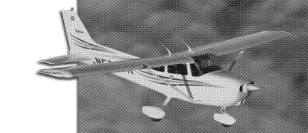



Released in 1977. the Cessna 172 Skyhawk is the successor to the Model 140. It has improved on the Cessna Model 140 by replacing the old 85 horsepower Continental C engine with the newer 160 horsepower Lycoming O-320-H2AD engine. This engine was more powerful due to increased piston size.

You will also notice that Cessna opted for a nose gear configuration, meaning that the tail wheel has been moved up and placed underneath the nose. This makes landing much easier, as the plane will no longer tend to fall on its nose under heavy braking. This innovation is incredibly important as now the pilot can use a heavier application of the brakes, shortening the distance for landing.

Regarding performance, the Skyhawk has a max cruising speed at level flight of 140mph, and a never exceed speed of 188mph.

**Part C: Introduction to yaw**

Yaw is the horizontal axis of direction that aircraft can traverse. The yaw axis is described in figure 3 with the arrows around the vertical axis. Yaw is simply another axis of motion that needs to be monitored in flight. To manipulate or stabilize an aircraft around its yaw axis, one uses the combining systems of rudder and the vertical stabilizer, which is explained in the next chapter.

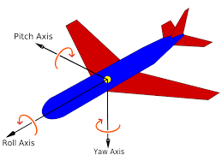

**Figure 5 ^, the major axis of aircraft motion. Pay special attention to the Yaw axis.**

**Chapter 2: Cessna Rudder Control Surfaces**

**Part A: The Vertical Stabilizer**

The yaw of an aircraft is stabilized and kept still using the vertical stabilizer. The vertical stabilizer is the long “shark fin” on aircraft. If you are having trouble picturing this, imagine the large planes at the airport. Now focus on the tall fin towards the rear. This long fin usually has the airliner logo printed on it. This fin, is the vertical stabilizer. It is pictured in figure 4. The vertical stabilizer is static and does not move.

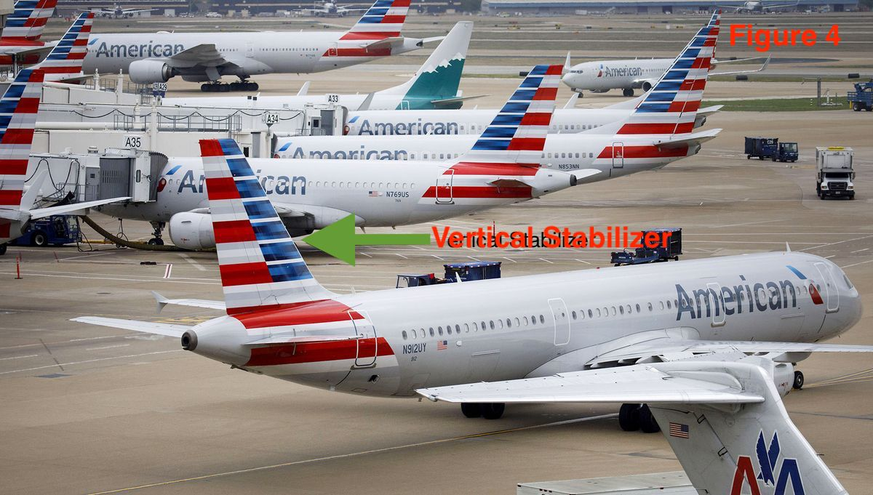Figure 4 (Typical vertical stabilizer on a on a commercial airliner).

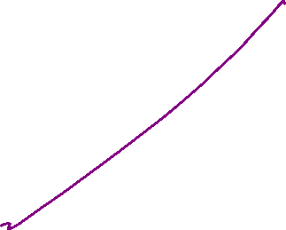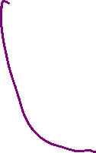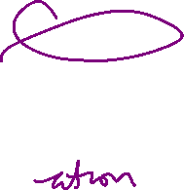

**Part B: The Rudder**

The yaw of the aircraft is manipulated by the rudder. The rudder is a hinged surface (figure 5) that is on the trailing edge (the edge towards the rear) of the vertical stabilizer. This surface can have its angle manipulated to direct air flow to the left or right side of the aircraft. This directing of air creates and equal force in the opposite direction on the rudder, which then points the nose to the left or the right. 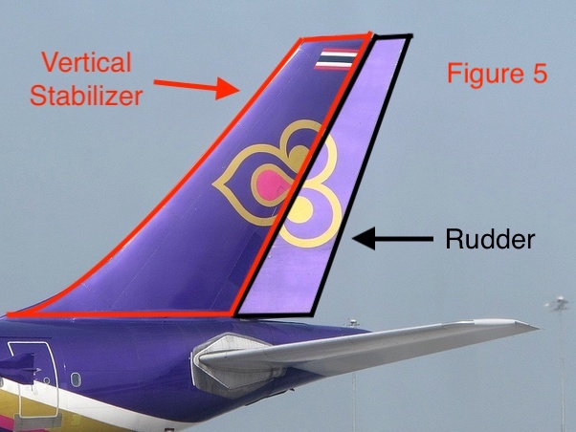



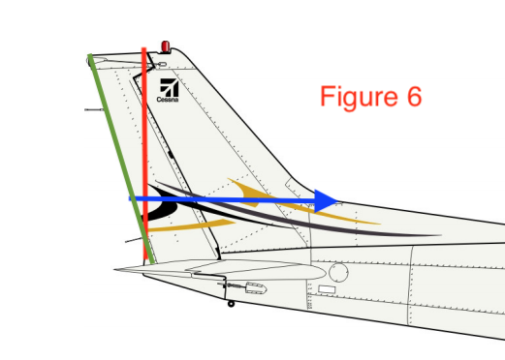You will notice three different color lines drawn over this technical photo (Figure 6; (Owners Manual 1977)) of the Cessna 172’s rudder.



They each represent different dimensions, listed below (Clark 2017)

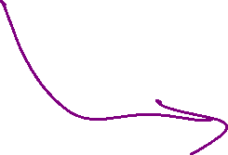

The BLUE line, which is the width of the vertical stabilizer, is 4ft 5in

The RED line, which is the height of the vertical stabilizer, is 5ft 1in



The GREEN line, which is the heigh of the rudder, is 6ft

**Chapter 3: Cessna Rudder Control Mechanism**

**Part a: Cables**

The rudder is connected to two pedals at the pilots' feet by cables (Pictured in figure 7). As you can see below, the rudder has two cables connecting them to the pedals. This is so if one fails, the other can still allow control of the rudder. The pilot will feel the loss of one cable in his/her feet, and will require more force to move the rudder, but the plane can still be controlled to ensure a safe landing (Price 2019).



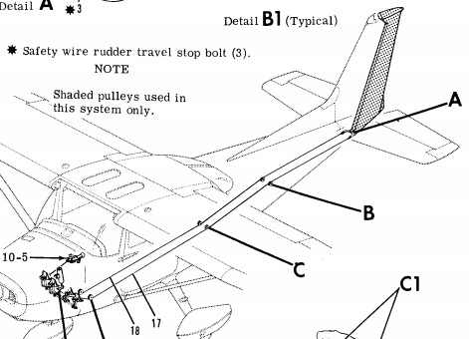

Figure 7 (Owner's Manual, 1977)



**Part b: Pedals**

The pedals consist of two steel plates, connected to cables that run to the rudder. You can think of the pedals as an equivalent of a steering wheel: if you press the left pedal, the nose will point to the left, if you press the right pedal, the nose will point to the right. Figure 7 is an image of one of the Skyhawk’s rudder pedals. You will notice grooves for extra traction. This is to prevent your foot from slipping (Clark 2017).

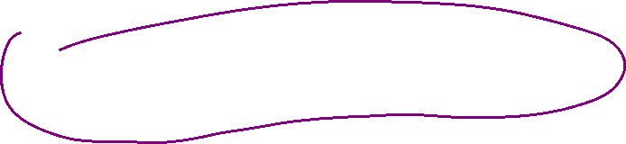

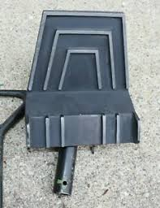Figure 8



**Chapter 4: Conclusion**

Rudders are a simple, yet crucial component of aviation. A rudder allows the pilot to control the yaw axis of an aircraft.



Aircraft without engines have come back, but aircraft without control surfaces have not. As evidenced by the control system in the Cessna, rudders employ a redundant cable system that makes them resistant to failure. Redundancy and simplicity are crucial to ensure flight safety.



This technical document shows how the cable powered rudder in the Cessna controls the yaw of the aircraft. Furthermore, there is an explanation regarding the importance of yaw. Please refer to the table of contents to find what you are looking for.



**References:**



1. Cessna. (1977, February). Cessna Model 172 Skyhawk Series Service Manual 1977. Retrieved from <http://www.aeroelectric.com/Reference_Docs/Cessna/cessna-maintenance-manuals/Cessna%20172%20Skyhawk%20Service%20Manual%20(1976).pdf>



1. Cessna Skyhawk 172 Owner's Manual. (1977). Retrieved from <http://www.aeroelectric.com/Reference_Docs/Cessna/cessna-maintenance-manuals/Cessna%20172%20Skyhawk%20Service%20Manual%20(1976).pdf>
2. Cessna 120/140. (2009, September 10). Retrieved March 10, 2021, from <https://www.aopa.org/go-fly/aircraft-and-ownership/aircraft-fact-sheets/cessna-120-140>



1. Clark, A. (2017, July 05). All about the Cessna 172 SKYHAWK. Retrieved March 04, 2021, from <https://disciplesofflight.com/cessna-172-skyhawk/>
2. Foundation, P. (1987). Nonstop Europe & back. Retrieved March 10, 2021, from <https://www.panam.org/pan-am-stories/571-no-goose-no-gander>
3. History Cessna. (n.d.). Retrieved March 04, 2021, from [https://web.archive.org/web/20110318220824/http://www.cessna.com/CessnaHistory/His/History-1960-1969.html](https://web.archive.org/web/20110318220824/http:/www.cessna.com/CessnaHistory/His/History-1960-1969.html)
4. H2AD engine. (2020, February 05). Retrieved March 04, 2021, from <https://cessnaowner.org/h2ad-engine/>
5. Murrows, M. (1990). Cessna CR-3 HISTORY. Retrieved March 10, 2021, from <http://www.aeroaces.com/cr3history.htm#:~:text=On%20July%204th%2C%20the%20CR,of%20the%20four%20speed%20runs>
6. National aviation Hall of Fame REVEALS "class of 2018". (n.d.). Retrieved March 04, 2021, from <https://www.nationalaviation.org/national-aviation-hall-fame-reveals-class-2018/>



1. Price, C. (2019, July 23). Pros and cons of tailwheel aircraft. Retrieved March 10, 2021, from <https://www.asapaerospacehub.com/blog/pros-and-cons-of-tailwheel-aircraft/>
2. Shupek, J. (n.d.). Cessna 140, Single-engine two-seat High-wing light CABIN MONOPLANE, USA. Retrieved March 04, 2021, from <https://www.skytamer.com/Cessna_140.html>
3. State, national & International Aerospace Trending Resources. (2007, April 29). Retrieved March 04, 2021, from <https://wingsoverkansas.com/phillips/a66/>



Audience Profile Sheet

**AUDIENCE PROFILE SHEET**

**Reader’s Name:** N/A



**Reader’s Job Title:** N/A. (Definitely not an aircraft mechanic or pilot)



**Education:** High School education required for comprehension of mechanics and forces

**Professional Experience:** None Required



**Job Responsibilities:** N/A

**Personal Characteristics:** Either a Need to know about the subject, or a driven interest

**Cultural Characteristics:** Curious, driven to learn

**Attitude Toward the Writer:** Desire for a good, clear product in the form of a comprehensive technical document to satisfy the reader's needs.

**Attitude Toward the Subject:** Either a need to know, or a given interest.

**Expectations About the Subject:** Expected difficulty, in addition to lack of foreknowledge.

**Expectations About the Document:** Highly technical.

**Reasons for Reading the Document:** Interest in subject or need to know.

**Ways of Reading the Document:**

Skim it _Yes__ Study It _Yes__ Read a portion of it _No__ Which portion?

Modify it and submit it to another reader _if qualified__

Attempt to implement recommendations __Yes_

Use it to perform a task or carry out a procedure __Only if qualified_

Use it to create another document _No__

Other ___ Explain

**Reading Skills:** High School reading skills, knowledge of mechanics, ability to imagine and comprehend 3-D spaces

**Reader’s Physical Environment:** This depends on the readers skill and foreknowledge above the minimum level. If the reader is skilled in technical matters, then this document could be read sitting on the train, or sat next to his damaged aircraft on a busy tarmac (both distracting environments). Silence for the inexperienced reader.

**Reflection**



The genre of this assignment is a technical description. This is because it has the purpose of describing an item technically (in detail) to a specific audience. Furthermore, this document follows the rubric and composition of a technical description. The components of this document include: Historical context, diagrams of the item, descriptions of the functions of the item, the purpose of the item, and the construction of the item. These are all the components of a technical description.



All technical descriptions use a medium. The medium varies wildly by audience. For example, in an office, I may bring a printed copy to my boss. Or I may use a PowerPoint at a meeting. In another meeting I may find PowerPoint too boring and distracting, so I may conduct my technical description verbally, with only diagrams to help. In this case, I am using a digital medium for my technical description.



My audience is a wide one because I allowed a wide variety of people to read it by omitting overtly difficult words and inserting many definitions of the difficult words that I do use. One group of people who are not in the boundaries of my audience are those without a high school education. This is because that is the bare minimum for the reading comprehension required to understand this document. That being said, some middle schoolers may have no problem understanding this technical document. Other people not in the boundaries of my audience are those with an extreme amount of knowledge on the subject. This means that mechanical and aerospace engineers will not be reading this document. Along with pilots, aircrew, ground crew, manufacturers, and more intense aviation enthusiasts.

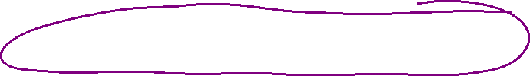

Now that my audience is known, I can delve into my purpose. The purpose of this technical document is to describe to my audience the 1977 Cessna Skyhawk Rudder. This encompasses the rudders' purpose, mechanisms, redundancies, materials, and usage.



During the course of constructing this technical document, I have expanded on many course learning outcomes. I used the art of rhetoric to formulate a comprehensive description of my item, the Skyhawk rudder. By being explanatory and descriptive, I distinguished this technical description from other types of documents.

I learned the real difference between different genres by attempting to create a document of a certain genre (technical description), which in turn taught me all the subtle nuances in between different genres. By specializing in one genre, I actually learned that there are really peculiar differences that separate them. Before this assignment, it appears that many genres overlap considerably, making one doubt the differences.

Via the act of communicating with peers, bouncing ideas, and giving criticisms, I used a collaborative approach to better my writing ability. I personally received very good criticism, and can only hope that I returned the favor. Me and a few of my colleagues have been in communication via texting, working to lift each other up. I feel better prepared for work as an engineer, which will be mostly in teams.

With regards to stance, in a technical description there can be but one stance: neutral. It is not my goal to sell the product, nor to attack it. I have learned that it is easy to let personal opinions slip into your writing. This learning was only possible as a result of me trying to maintain a neutral stance.



The exigence of my work is that there is a situation in which my subject, the Cessna 172 rudder and control system, requires a detailed explanation. This is the root point of my work. My audience needs this information, for a wide variety of reasons.



I hope to have learned much from this writing adventure into a new genre. I am looking forward to receiving critical feedback.

